# 05 August, 2025

Gooning Ventures

8, Shepherd Rd, Police Colony, Nagpada, Byculla, Mumbai, Maharashtra 400008 [contact@gooningventures.ac.in](mailto:contact@gooningventures.ac.in) [www.gooningventures.com](http://www.gooningventures.com)

**MEETING NOTICE**

To,

The Project Team Members.

Subject: Notice for project manegement Meeting Dear Team Members,

You are hereby informed that a meeting has been scheduled to discuss the current status of the ongoing project and plan the next phase.

Date: 06 August, 2025. Time: 11 am. Venue: Conference room, 2nd floor.

Your presence is mandatory.

# AGENDA OF THE MEETING

The following points will be discussed in the meeting:

1. Welcome and Introduction
2. Review of Current Project Progress
3. Discussion on Pending Tasks and Issues
4. Resource Allocation and Timeline Adjustments
5. Feedback from Engineers
6. Planning the Next Phase of the Project
7. Any Other Business
8. Vote of Thanks

Prepared by: **Yamin Khan (IT Manager)**

Regards,

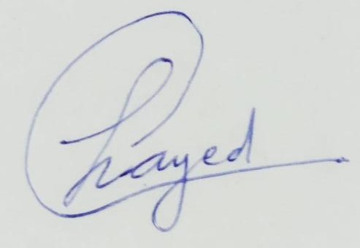

# Haadiya Sayed (Project Manager)

**MINUTES OF THE MEETING**



Gooning Ventures

8, Shepherd Rd, Police Colony, Nagpada, Byculla, Mumbai, Maharashtra 400008 [contact@gooningventures.ac.in](mailto:contact@gooningventures.ac.in) [www.gooningventures.com](http://www.gooningventures.com)

**DATED: 6 August, 2025, AT 11AM IN THE CONFERENCE ROOM**

**A MEETING ON Project Management AND PROBLEM ANALYSIS AND SOLUTIONS**

Members Present:

Ms. Sayed Haadiya Aejaz Husain (General Manager)

Mr. Qureshi Abdur Rahman Mohammed Vakil (Assistant Manager)

Ms. Sofiya Patwekar (Project Client)

Mr. Shahid Zahid Mohammed (Developer 1)

Mr. Mohammed Anas Amin Nathani (Developer 2) Ms. Sayyed Nahid Daavar (Tester)

Mr. Shaikh Mohammed Rumaan Izharul Haq (Marketing) Mr. Shaikh Abdul Sameer Abdul Saeed (Finance)

Mr. Khan Yamin Abdul Wahid (IT Manager)

Welcome and Introduction:

The meeting commenced with a warm welcome and introduction to the subject of today's meeting by the chairperson of the meeting Ms. Zainab Mirza (IT HOD)

Discussion Points

1. Assistant Manager opened the meeting and reviewed project objectives.
2. Developers presented chatbot’s base built using GPT-4 API with login and dashboard functionality.
3. Multilingual support (Hindi, Marathi, Tamil) is under development to reach more students.
4. Tester reported successful Unit and Integration testing; highlighted confusion on outdated syllabus data.
5. Marketing team shared teaser campaign plans with slogan 'Talk Smart. Study Smarter'.
6. Finance reported 60% budget usage; additional funds may be needed for multilingual integration.
7. Engineers suggested live chat fallback option for unhandled queries, to be added in v2.0.

Key Decisions:

1. Dataset filtering will be improved to avoid outdated info.
2. Revised budget proposal to be submitted by Friday.
3. Pilot version to launch by end of the month in two partner colleges.
4. Fallback live chat feature planned for v2.0.

Conclusion, Vote of Thanks & Next Meeting:

The meeting concluded with a summary of action points and a vote of thanks by the General Manager. The next review meeting is scheduled post pilot testing completion.

Prepared by Mr. Yamin Khan

(IT Manager)



**Haadiya Sayed (General Manager)**